**CS3006 Parallel and Distributed Computing**

**Week13**

**Fall 2022**

**Task#1**: Implement the following MPI code snippet as shown in Figure using four processes (P0, P1, P2, and P3). **Display the receive buffer of each process for each numbered call (I, II, III, IV, V).**

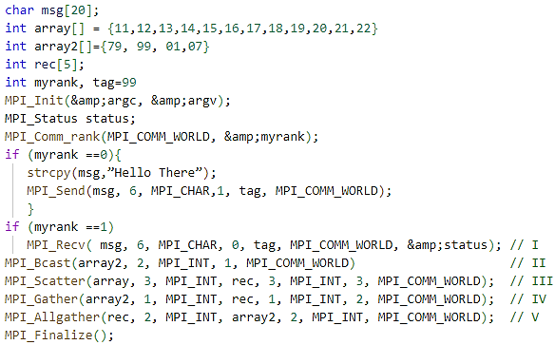

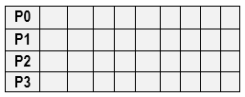

**Task#2:** Implement the **Merge-Sort** algorithm to sort an array of 100 elements in parallel using MPI. You must implement recursive decomposition of data.